﻿
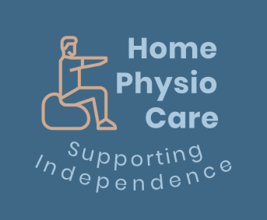
Home Physio Care Ltd Customer Privacy Notice

This privacy notice tells you what to expect us to do with your personal information.

Our contact details
Email: homephysiocare@outlook.com

What information we collect
- Name, address, email and contact details including next of kin (in case of emergency)
- Reasons for contacting us and details about your health & medical condition(s)
- Clinical records once treatment has commenced
How do we get the personal information
- By yourself or whomever made the initial enquiry about your suitability for our services
- With your consent, we may seek relevant information from third parties such as the NHS, your care provider or other professionals involved in your care
How do we use this information
- To provide you with information and services from us
- To notify you about any changes to your appointments or our services
- To maintain up to date clinical records
- To maintains general communication as appropriate
- To analysis the demographics of our service users
Under UK general data protection regulation (UK GDPR), the lawful bases we rely on for processing this information are:
1/ Your consent. You have a right to remove your consent at any time by contacting homephysiocare@outlook.com.
2/ We have a professional obligation and responsibility under our governing body the Health & Care Professions Council.
How do we store your information

Personal information is stored on our secure clinical records system which meets GDPR regulations. It will remain in the UK. Data will be kept in active files for as long as you are receiving treatment for, after which it will be archived for 8 years.

Other organisations we may need to share information with:
- Health care or social care providers with your consent
- Organisations we need to share information with for safeguarding reasons
- Relevant regulatory authorities
- External auditors or inspectors
- Organisations we’re legally obliged to share personal information with
- Emergency services (where necessary)

Your data protection rights
Under data protection law, you have rights including:

Your right of access
You have the right to ask us for copies of your personal data.

Your right to rectification
You have the right to ask us to rectify personal data you think is inaccurate. You also have the right to ask us to complete information you think is incomplete

Your right to erasure
You have the right to ask us to erase your personal data in certain circumstances.

Your right to restriction of processing
You have the right to ask us to restrict the processing of your personal data in certain circumstances.

Your right to object to processing
You have the right to object to the processing of your personal data in certain circumstances.

Your right to data portability
You have the right to ask that we transfer the personal data you gave us to another organisation, or to you, in certain circumstances.

Your right to withdraw consent
When we use consent as our lawful basis you have the right to withdraw your consent.

You don’t usually need to pay a fee to exercise your rights. If you make a request, we have one calendar month to respond to you. To make a data protection rights request, please contact on homephysiocare@outlook.com

How to complain
If you have any concerns about our use of your personal data, you can discuss it with us, or make a complaint to us at homephysiocare@outlook.com

If you remain unhappy with how we’ve used your data after raising a complaint with us, you can also complain to the ICO.

The ICO’s address:
Information Commissioner’s Office
Wycliffe House
Water Lane
Wilmslow
Cheshire
SK9 5AF
Helpline number: 0303 123 1113
Website: https://www.ico.org.uk/make-a-complaint

Last updated
22 July 2024

